**Front-end Ideation Flowchart**

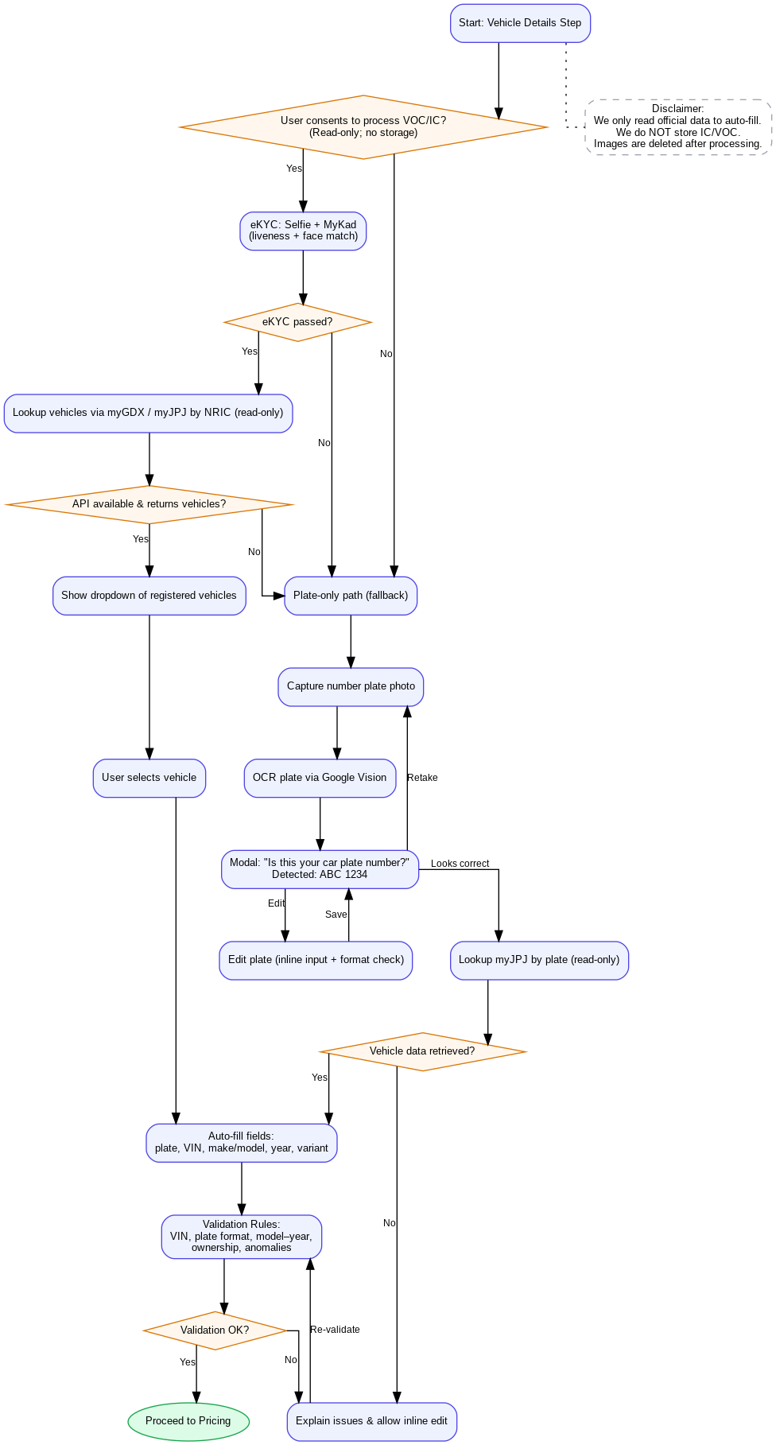

**Access to JPJ data (choose one)**

* **Direct JPJ integration (private sector path)** — Apply to JPJ for **read-only** queries (e.g., lookup by **plate**, possibly **vehicles by NRIC**). Precedent: private platforms handling road tax/insurance do this via contracts/appointments with JPJ. *(Refs: Malay Mail, The Edge Malaysia)*
* **Authorised intermediary (while you work on direct access)** — Partner with a provider that already has JPJ connectivity (e.g., **MyEG**) to broker allowed lookups, subject to JPJ rules & commercial terms.

**External (must-have)**

* **eKYC:** **ZOLOZ** by Ant International *(used by TnG)* — selfie + liveness + face match
* **Vehicle data (authoritative):** **JPJ Vehicle Registry** — lookup by **plate** (and, if permitted, **NRIC** / **VIN**) via **direct JPJ** or **authorised intermediary (MyEG)**
* **Plate OCR (fallback):** **Google Cloud Vision – Text Detection** — read plate text from photo → **always** show “Is this your plate?” model before any lookup